**UNIVERSITY OF PETROLEUM & ENERGY STUDIES**

**Lab Assignment : My Plugin**

Programme: B. Tech in Computer Science and Engineering with

Specialization in DevOps

Course: Continuous Integration & Continuous Delivery

Semester: V

Session: Aug-Dec 2022

Batch: 2020-2024

Faculty: Dr. Omkarendra Tiwari

**Submitted By:**

|  |  |  |
| --- | --- | --- |
| **Name** | **SAPID** | **ROLL NO** |
| **Rohit Kumar** | **500082652** | **R214220968** |

**Cybernetics Cluster**

**School of Computer Science**

**University of Petroleum and Energy Studies**

**Dehradun-248007**

**Step 1:** First create a plugin project for that I showed steps in screenshots:

• First go to File →New→ Other→ plugin project.

• Select →Next→ give name → press next and then select Hello, World Command →Finish

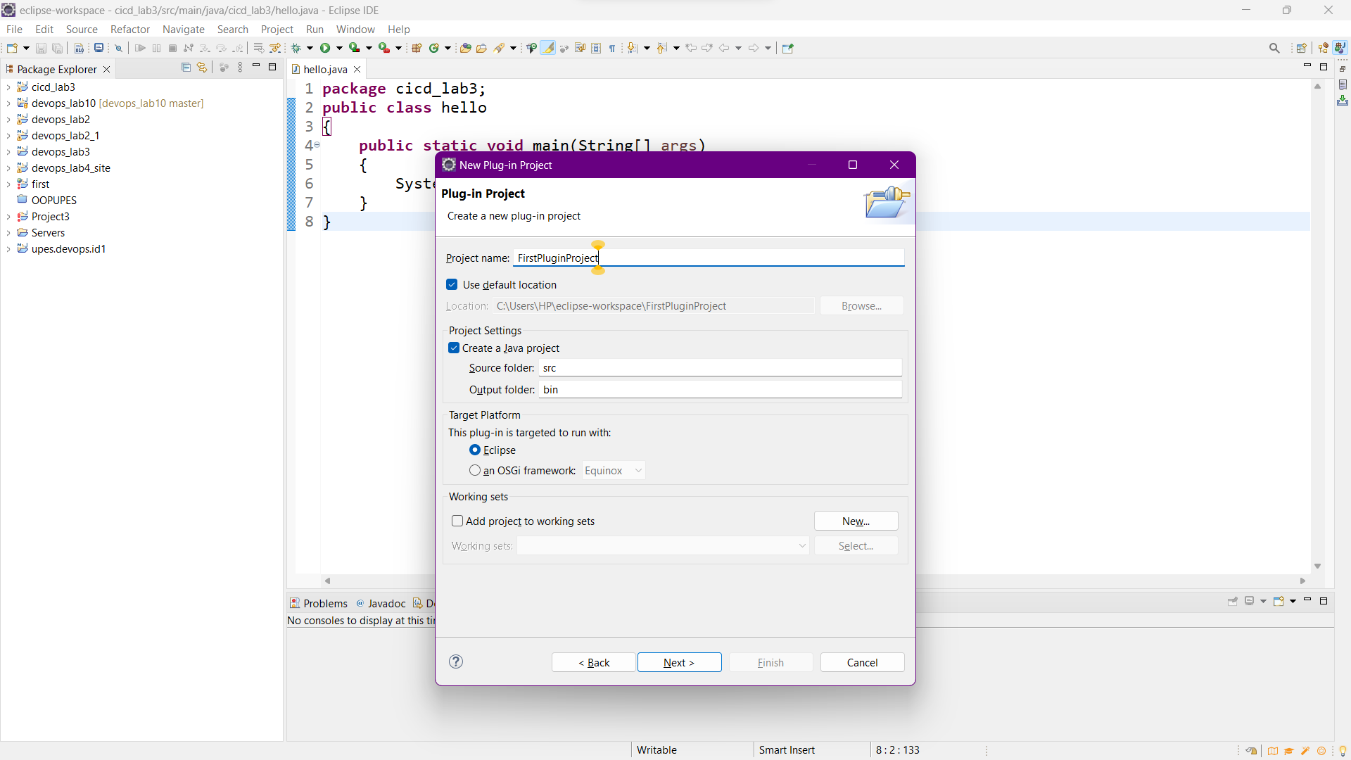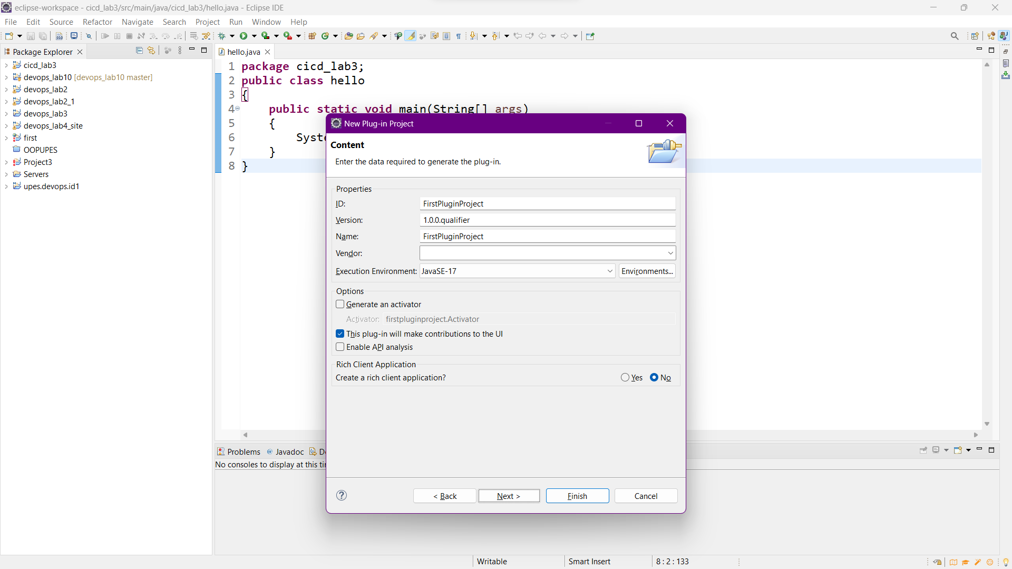

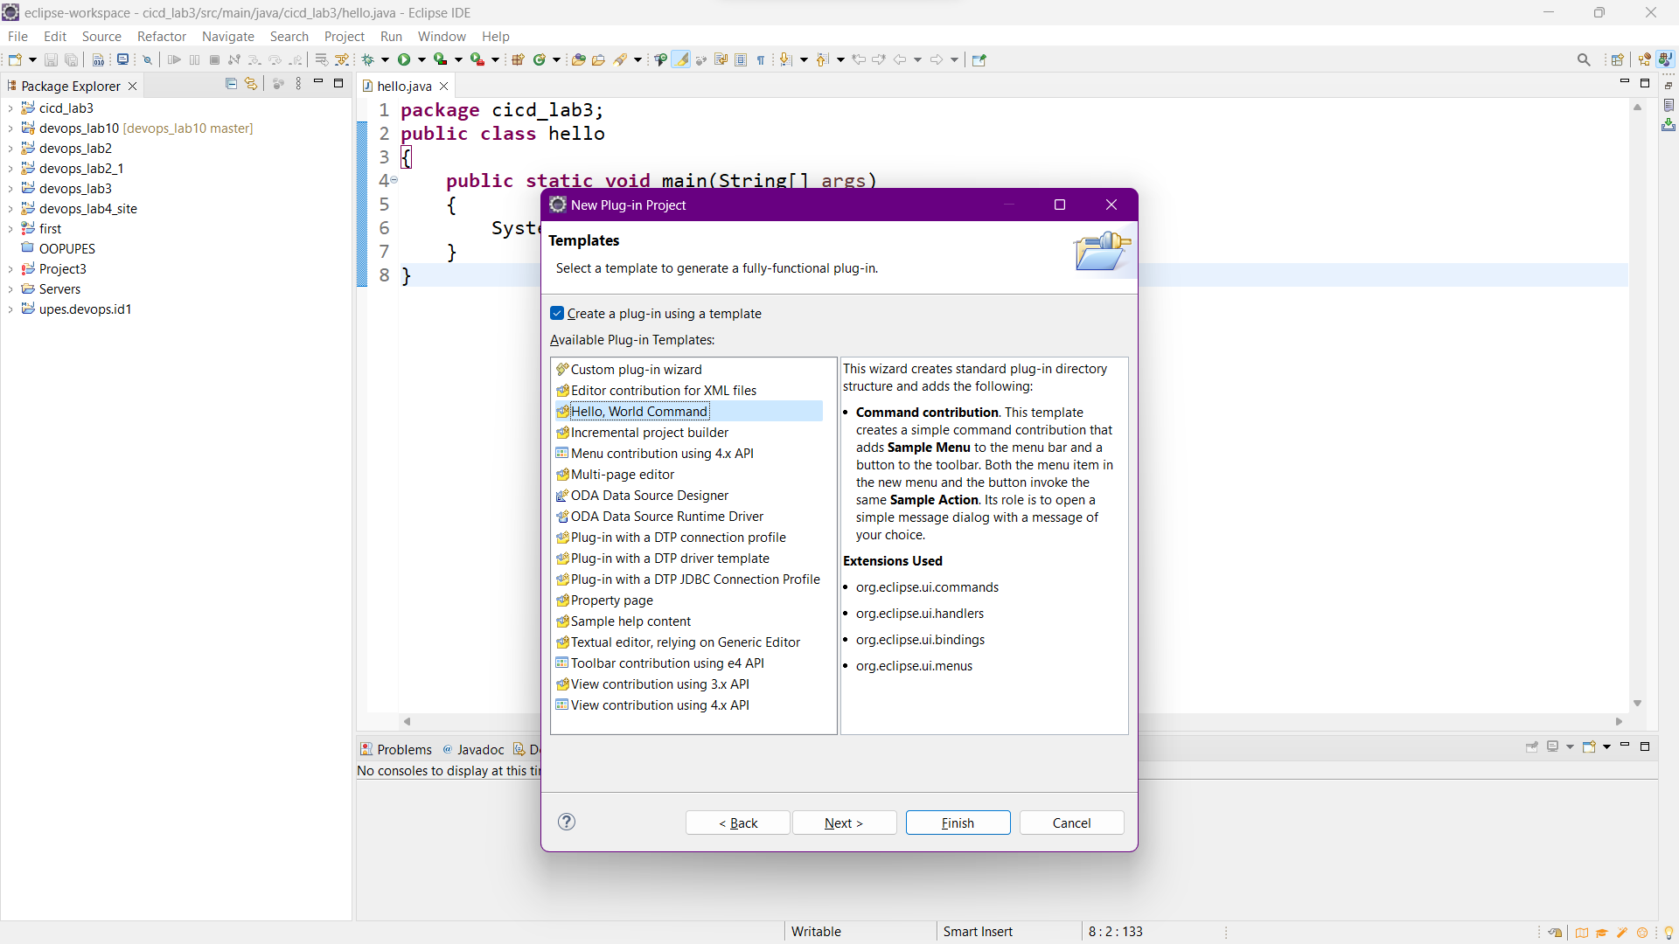

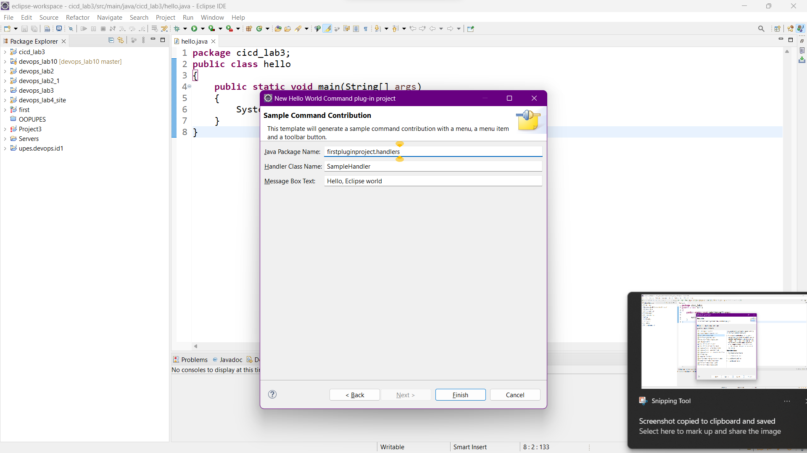

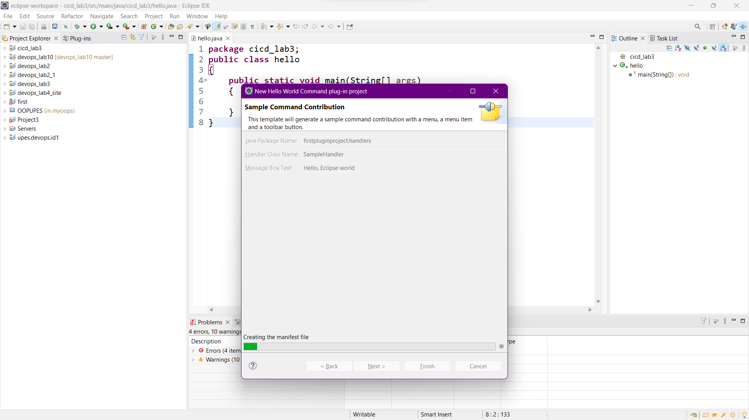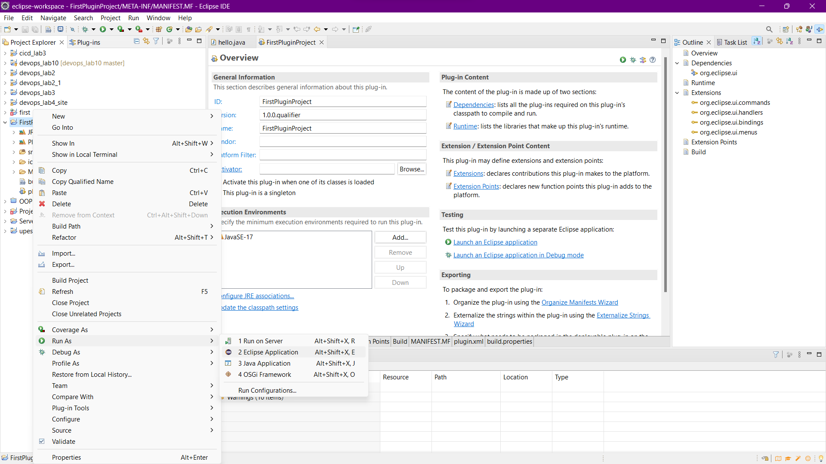



**Note:** If you run as an Eclipse Application there is a single Sample menu which will print a simple Hello message.

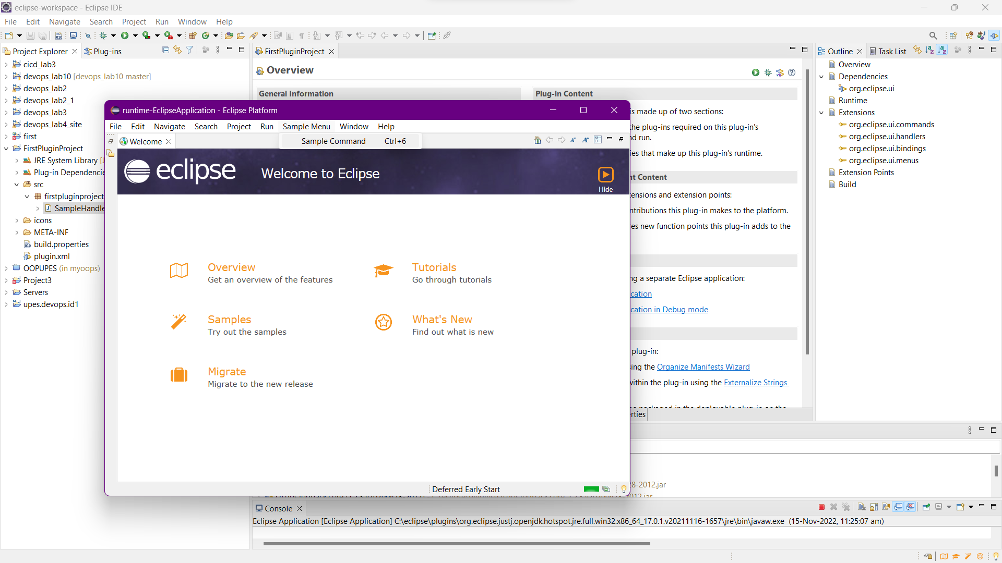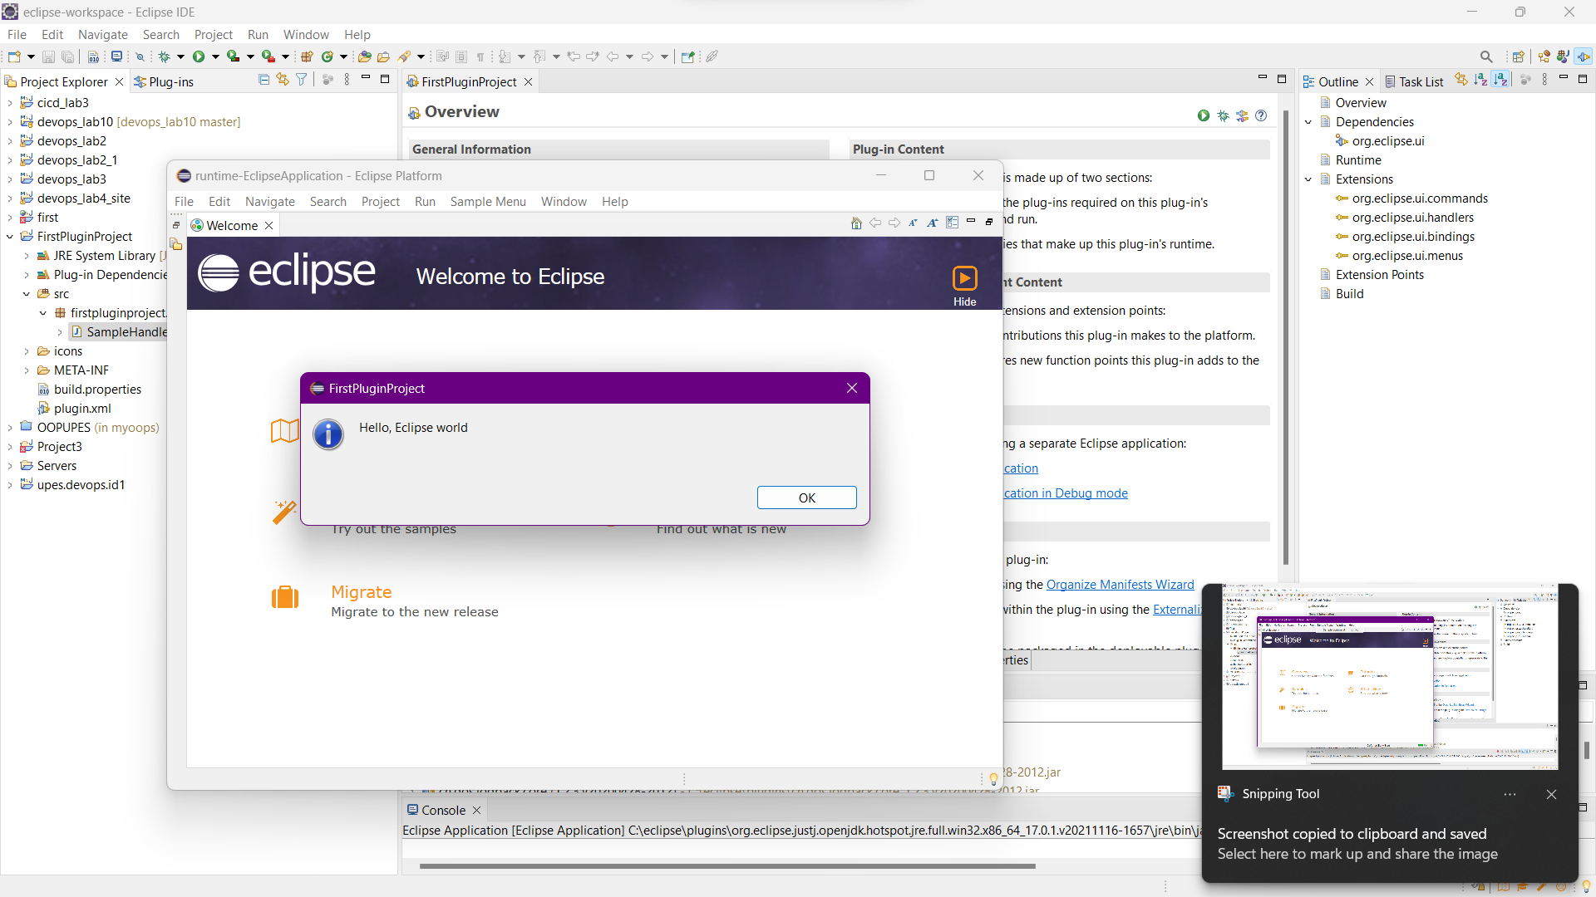

**Step 2:** To add another menu button with different messages we need to create anotherHandler.java file with some different messages in my case I have created a java file with the name SampleHandler1.java

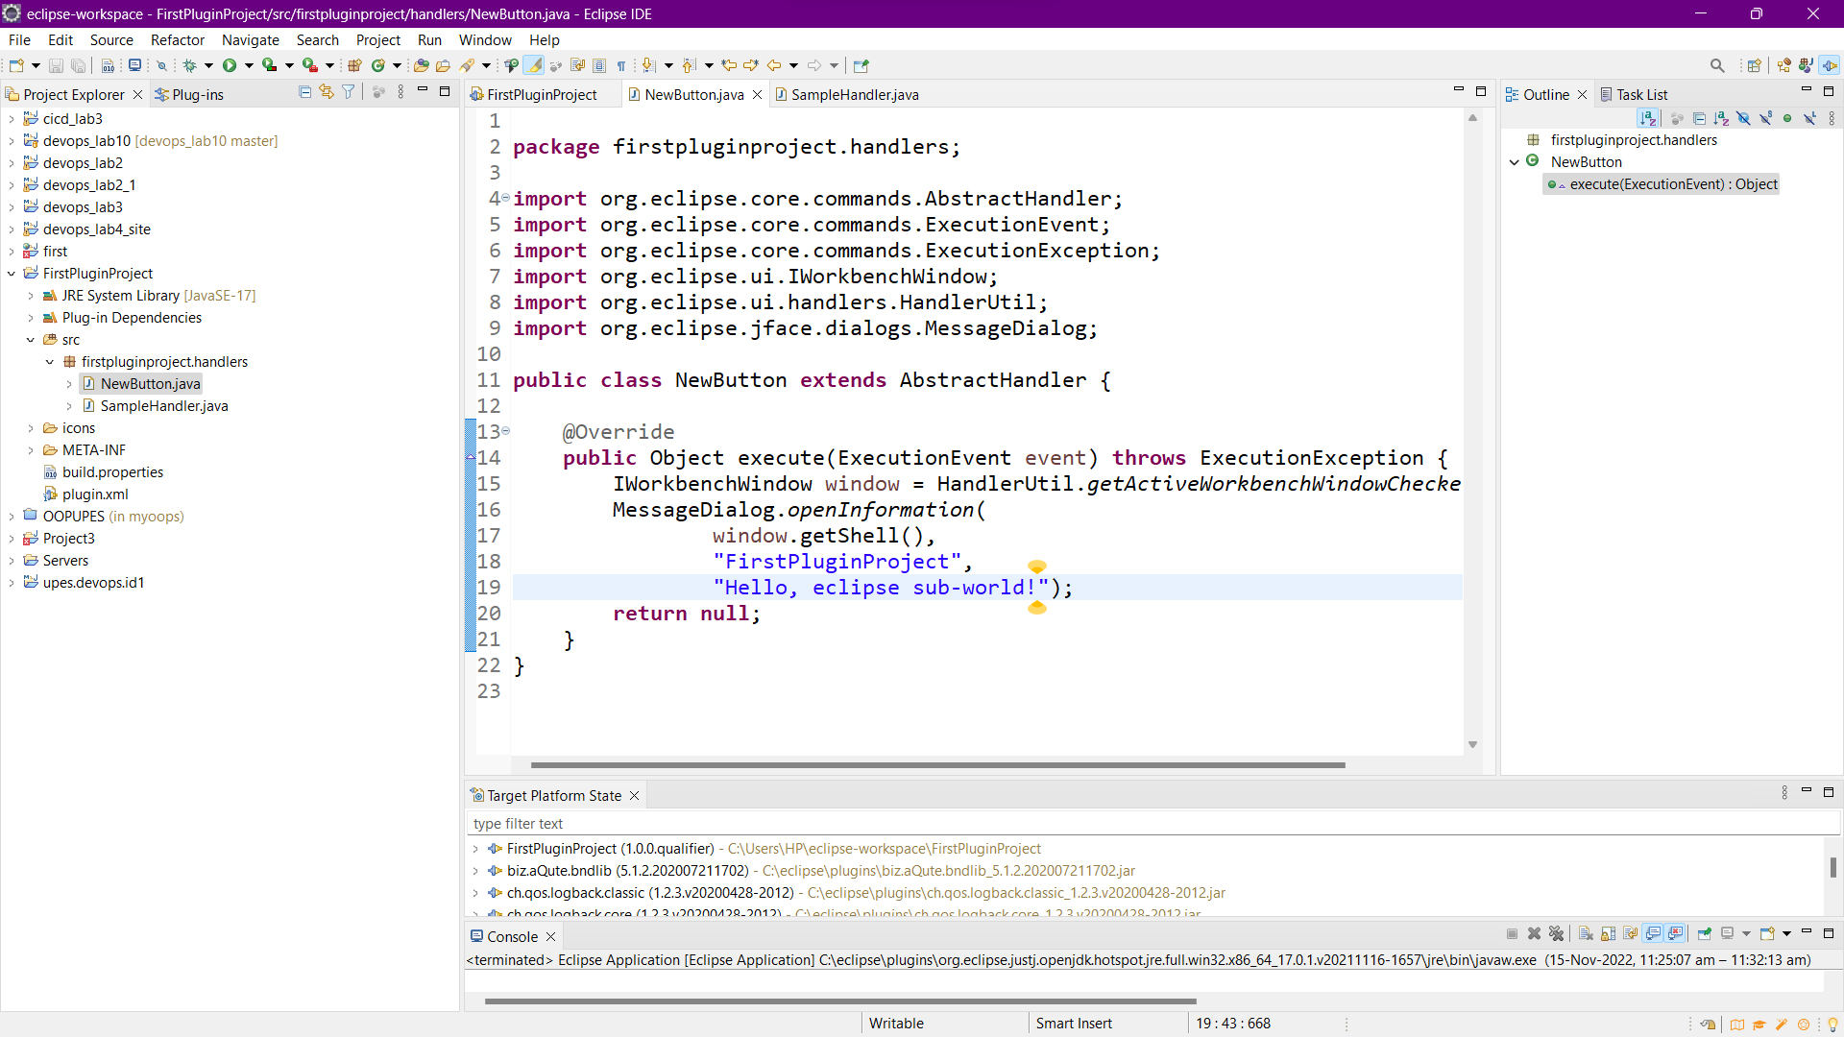

**Step 3:** Make changes in Extensions or in plugin.xml file.

This will create two menu buttons with different messages.

• Now the output will look like:

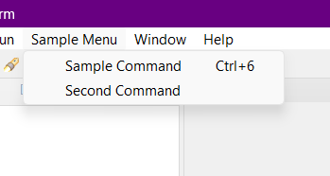

**Step 4:** Chek if both the buttons are working.

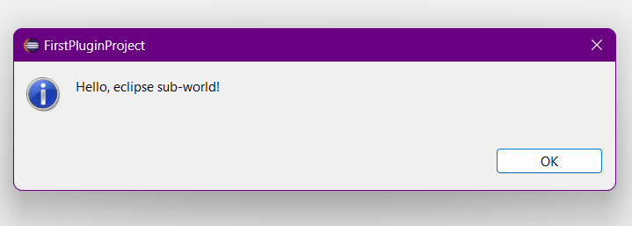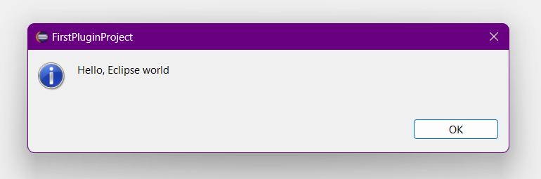

**CONCLUSION: *A new plugin has been created successfully with two buttons by simply making changes to the pom.xml file. Each of these buttons on being pressed, display different messages as described by us in the .xml file.***